Creating Accessible Microsoft Word Documents – Practice

Change text to a heading
- Assign the proper heading levels to the following text. See if you can use more than one technique.
- There are two sentences that should be changed to headings. Make this change, and make sure the heading levels are correct.
Branches of Government in the United States
There are three branches of government in the United States. These branches are defined in the U.S. Constitution.
Executive
The President of the United States administers the Executive Branch of our government. The President enforces the laws that the Legislative Branch makes.
Legislative
The Legislative part of our government is called Congress. Congress makes our laws. Congress is divided into two parts.
The Senate. There are 100 Senators––2 from each state. Senators serve for a term of 6 years.
The House of Representatives. Representatives meet together to discuss ideas and decide if ideas (bills) should become laws. There are 435 Representatives. Representatives serve for a term of 2 years.
Judicial
The Judicial Branch is the court system. It explains and applies the laws. This branch does this by hearing and making decisions on various legal cases.

Help

Creating headings
- Select the Home tab from the ribbon.
- In your document, select the text you are converting to a heading.
- Click on the appropriate heading level in the Styles in-ribbon gallery; e.g., Heading 1.
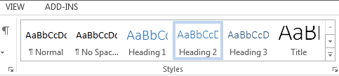
Note: Headings 1, 2, or 3 can also be assigned with the keyboard using Control + Alt + 1, 2, or 3, respectively.

The correct heading structure
Heading 1 - Branches of the Government in the United States
Heading 2 - Executive
Heading 2 - Legislative
Heading 3 - The Senate
Heading 3 - The House of Representatives
Heading 2 - Judicial

Modify appearance of an existing Style
Change the appearance of every "Heading 2" on the page so that it has the following appearance: Calibri Light font, 16 text size, dark blue color (or another color you prefer), bold.

Help
- In the Home tab, Right-click on the "Heading 2" Style in the Styles Gallery.
- Select "Modify"
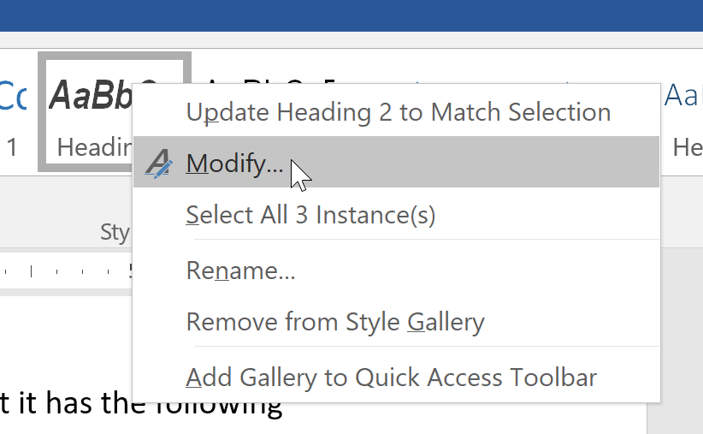
- Apply the styles in the "Modify Style" window.

Modify a Style's appearance match selection
In the previous example, you changed the appearance of the existing Heading 2 Style. In the next example, do the opposite. Update your "Heading 3" style so that it matches the appearance of this blue italicized text.
Every Heading 3 should look like me

Help
- Highlight "Every Heading 3 should look like me" above.
- In the Home tab, Right-click on the Heading 3 Style in the Styles Gallery.
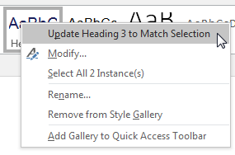
- Select Update Heading 3 to Match Selection.
Note: This will also turn this text to a "Heading 3".

Alternative text for images
Give these images descriptive alternative text.
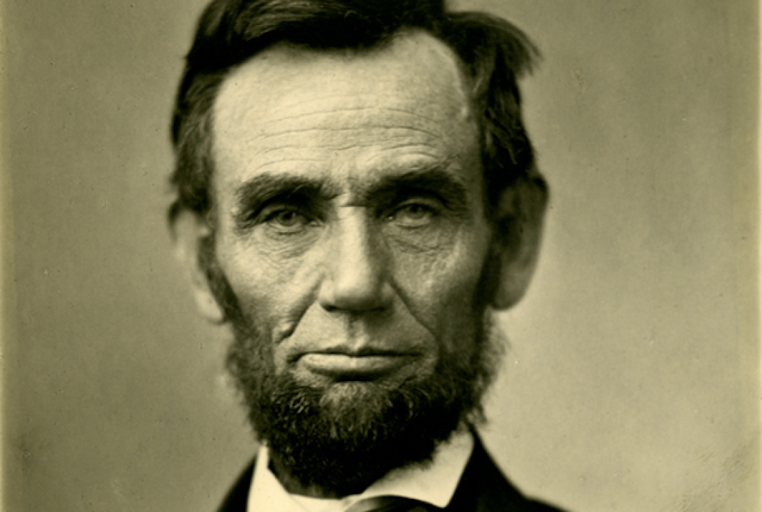

Help
- Right-click on the image and select Format Picture. A dialog box will appear.
- Select the Layout & Properties icon and choose Alt Text.
- Enter the appropriate alternative text only in the Description field, NOT the Title field.
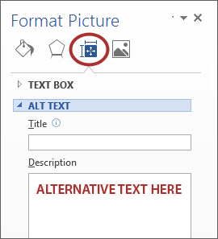
Note: One of the images is a link. Does that affect the alternative text?

Tables
- Update the table so the cells in the first column are identified as headers when exporting to PDF.
- Update the following table so that headers are clearly identified visually.

Class Name | Course Number | Location
Website Development | BIS 5650 | B105
Database Management | BIS 330 | B220

Help
- Click inside the table.
- Select Table Tools > Design tab (or Table Design tab on Mac) on the ribbon, and make sure the Header Row and First Column checkboxes are checked.
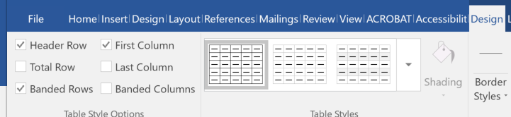
- In the Table Styles section, change the appearance of the table so the column and row headers are clearly identified visually.

Links
Make this Hyperlink text more descriptive.
Buy a license of Microsoft Office 2013- http://www.amazon.com/Microsoft-Office-Student-1User-Download/dp/B00B1TGUMG/ref=sr_1_3?ie=UTF8&qid=1403126508&sr=8-3&keywords=microsoft+word+2013

Help
- Select a hyperlink, right-click, and select Edit Hyperlink or Ctrl + K.
- Change the text in the Text to display field to "Buy a license of Microsoft Office 2013"
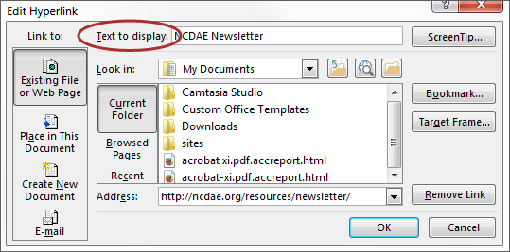
- Delete the redundant text that comes before the link.

Lists
Convert the following text into a list. Make sure you use the correct list type.
3 steps to making lists in Word
-Decide what type of list you should use—bulleted or numbered.
-Choose the correct list type.
-Spend the 5 minutes trying to get Word to stop auto-numbering

Help
- Highlight the text.
- Select the Home tab.
- Choose the Numbered List option from the Paragraph group.
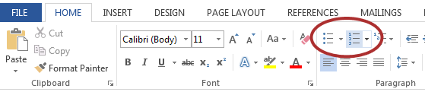
This should be a numbered list because there is an order to the options in the list.
- Separate each item in the list with the Enter key.
- Delete the dashes before each item in the list.

Creating Columns
The following text is in columns that were created with the Tab key. Recreate this text using true columns.
Don't use the Tab key and/or They may look OK, but the
Space bar to create "columns" reading order is all wrong. Plus,
in Microsoft Word documents. they are a pain to create and edit.

Help
- Select the Page Layout tab on the ribbon.
- Select Columns in the Page Setup group.
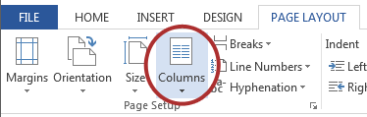
- Choose 2 columns.

Other principles
Address the accessibility issues in each of these sections.

Text size
- Text that is small can be difficult to read.

Contrast
Ensure contrast is sufficient.
Does this larger text need more contrast?

Help
- Download and install the Colour Contrast Analyser
- Select Options > Show Colour sliders > check RGB and HSV
- Use the Eyedropper to choose Foreground (or text) color
- If the background is something other than white, use the eyedropper to choose the Background color.
- Text needs at least 4.5:1 contrast.
  - Large text (14pt w/bold or larger, 18pt not bold or larger) needs 3:1 contrast.
- Use the bottom Value slider to find a color that passes the contrast requirements.
- In the Home tab, select Font Color > Custom, then enter the correct Red/Green/Blue values.

Color reliance
Assignment | Complete
1-Introduction | X
2-Lab | X

Check Accessibility
Run the accessibility checker and make the appropriate changes. What do you find helpful? Is there anything that it misses? Are there any false positives?

Help
- Select File.
- Click on Check for Issues > Check Accessibility.
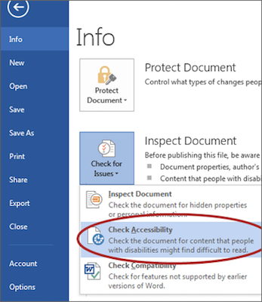
- Helpful
  - Image with missing alternative text
  - Table with no header row
- Misses
  - Text that should be a heading
  - Contrast and color reliance issues
  - No document title
- False positives
  - Alternative text for tables (in some versions of Word 2016)

Converting to PDF
Convert this file to PDF using the Acrobat plugin.

Help
- To export a PDF, select Create PDF from the Acrobat ribbon.
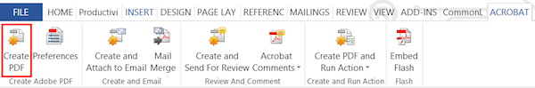
- Select Save.

